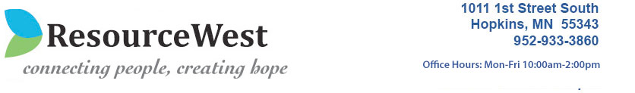
2017 Annual Report



ResourceWest is a non-profit community agency that serves low-income families and individuals living in the west metro community. We help people become more connected, more resourceful, and more hopeful about their future. From crisis, to action, to hope: the services of ResourceWest stabilize families and ultimately help build healthier communities one neighbor at a time.

ResourceWest assists families by addressing immediate needs and working toward long-term stability and self-sufficiency. We build a healthier and stronger local community both through direct services and a vast array of collaborations.

Mission: ResourceWest supports individuals and families in the West Metro through collaborative programs and connections to resources as they move toward greater stability

Who we serve
More Than

1 in 3
students in the Hopkins school district qualifies for free or reduced lunch

46
languages spoken by families in the Hopkins and Minnetonka School Districts

$1,000-$1,500
is the median monthly income for households who participated in the Children and Youth Programs in 2017

35.4%

12.4%
percentages of households in Hopkins and Minnetonka, respectively, below the federal poverty income level

REACH
Our core programs serve people of all ages and socio-economic backgrounds with a deep impact in the western suburbs. Our children’s programs reach the cities of Minnetonka, Hopkins, Excelsior, Shorewood, Deephaven, Woodland, and Greenwood. We are especially needed by individuals and families who do not meet eligibility criteria for state and county assistance programs or other nonprofit agencies.
BUILDING STRONG COMMUNITIES
To create healthy and vibrant communities, residents need to be able to access pathways out of poverty. Our program model provides access to resources that promote foundational stability in addition to empowering individuals and families to move towards self-sufficiency. As a well-known entity in the community, we have the relationships to meet emerging needs.

PROGRAMS FINANCES

Children and Youth Programs
Provide free school supplies, winter gear and gifts for the holidays for any family that attends the Hopkins and Minnetonka School Districts.

Social Service Programs

Case Management
ResourceWest’s case managers help families stabilize their situation, and continue to work with them to move to greater stability.

Emergency Bridge Assistance
These one-time emergency grants are most often related to transportation challenges (e.g. gas cards, bus fare cards, car repairs, etc) and healthcare (e.g. HMO premium payments, prescriptions, etc).

Information and Referral Service
Staff answers questions and offers referrals to other agencies that assist with food, clothing, shelter, healthcare, etc.
Collaborative Programs
ResourceWest hosts several outside agencies onsite in recognition of the challenge of limited and costly public transportation in the western suburbs.

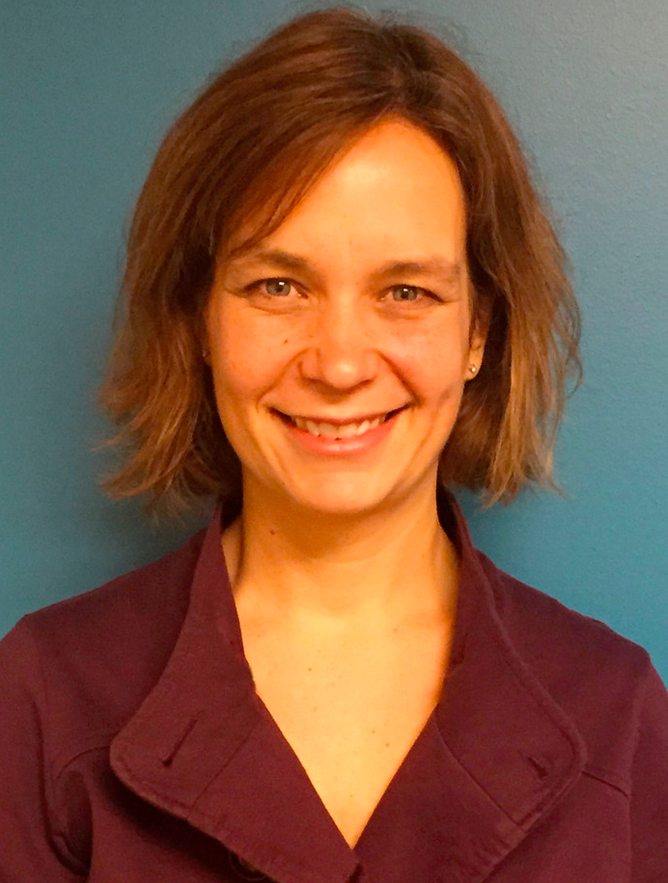

STAFF
Message from the Executive Director

I am profoundly impacted by the people I meet every day. The participants are working through such complexity, that the resilience required is so important. As a community resource, we are committed to welcoming and coming alongside all people
The donors and volunteers give of their resources so generously. ResourceWest has been locally supported for 25 years – our partnerships with individuals, businesses, faith communities, the Hopkins and Minnetonka Schools, partnering organizations – only increases our capacity to reach the needs of the entire community.
The staff’s knowledge and empathy is critical to supporting participants as they put one foot in front of another. It is critical, to continually learn together, because with learning, comes understanding, which leads to greater compassion.
All together, we are a community – working towards the best life we can.
-Tarrah Palm
Executive Director, ResourceWest
Tarrah Palm, Executive Director
tarrah@resourcewest.org
Stefan Dudziak, Program and
Community Engagement Coordinator
stefan@resourcewest.org
Kirsten Anderson, Licensed Social Worker
kirsten@resourcewest.org
Jamal Geedgale, Case Manager
jamal@resourcewest.org

BOARD OF DIRECTORS
Kim Hunwardsen, President
Jason Allerding, Vice President
Paul Patefield, Treasurer
Mahad Mohamed, Director
Jon Barsness, Director
Ann Davy, Director
Alyssa Hirschfeld, Director
Laurie Levi, Director
Lynn Rusch, Director
Dale Searles, Director
Linda Gardner, Director
Amy Saldanha, Director

Resourcewest
Statement of Financial Position
As of June 30, 2017

 | Total
 | As of Jun 30, 2017 | As of Jun 30, 2016 (PP) | As of Jun 30, 2016 (PY)
ASSETS
Current Assets
Total Bank Accounts | $162,204 | $169,348 | $169,348
Total Other Current Assets | $1,474 | $1,827 | $1,827
Total Current Assets | $167,517 | $171,355 | $171,355
TOTAL ASSETS | $167,517 | $171,355 | $171,355
LIABILITIES AND EQUITY
Liabilities
Total Accounts Payable | $1,571 | $3,165 | $3,165
Payable to ISD #270 | 0 | 2,228 | 2,228
Payable to ISD #270 - Accrual | 2,401 | 0 | 0
Deferred Revenue | 0 | 25,000 | 25,000
Community Needs Fiscal Agent | 0 | 8,520 | 8,520
Payroll Deductions Payable | 901
Accrued Expenses | 8,918
Total Liabilities | $ 25,588 | $ 38,914 | $ 38,914
Total Equity | $141,928 | $132,441 | $132,441
TOTAL LIABILITIES AND EQUITY | $167,517 | $171,355 | $171,355

Resourcewest
Budget vs. Actuals: FY 17 – FY 17 P&L
As of June 30, 2017

 |  | Jun-17 | Jun-16 | YTD | Prior Year YTD | FY 17 Total
 |  | Actual | Actual | Actual | Actual | Budget
 | Revenue
1 | Employee Give Campaigns | 0 | 0 | 9,558 | 6,030 | 8,000
2 | Civic | 0 | 0 | 5,150 | 14,041 | 10,000
3 | Individuals | 5,208 | 4,288 | 80,072 | 73,446 | 75,000
4 | Businesses | 550 | (5,000) | 9,804 | 19,194 | 12,000
5 | F Community | 20 | 0 | 22,479 | 8,499 | 15,000
6 | Grants - by Class | 7,083 | (24,200) | 36,500 | 78,320 | 45,000
7 | City, State & School Grants | 5,030 | 5,000 | 38,605 | 38,978 | 38,000
8 | Miscellaneous Revenue | 621 | 100 | 621 | 100 | 0
9 | Interest Income | 26 | 30 | 267 | 233 | 200
10 | Annual Fundraiser | 0 | 5,025 | 40,684 | 45,795 | 40,000
11 | Empty Bowls | 34,248 | 33,444 | 36,598 | 35,620 | 38,000
12 | Program Service Fees | (210) | 0 | 0 | 300 | 400
13 | Portico Subgrant Revenue | 158 | 400 | 712 | 1,000 | 950
 | Total Revenue | 52,734 | 19,087 | 281,049 | 321,556 | 282,550
 | Expenditures
14 | Total Payroll, Taxes and Benefits | 28,713 | 13,467 | 207,866 | 180,381 | 204,791
15 | Total Contract Services | 880 | 736 | 10,641 | 58,479 | 7,750
16 | Total Other operating expenses | 939 | 1,906 | 31,458 | 31,953 | 34,950
17 | Program | 0 | 3 | 3,947 | 3,553 | 6,000
18 | Emergency Supplies | 805 | 572 | 10,585 | 15,598 | 14,000
19 | Administration Fees | 105 | 500 | 2,415 | 6,000 | 2,940
20 | Space Lease | 387 | 333 | 4,649 | 4,649 | 4,644
21 | Total Expenses | 20,906 | 1,570 | 9,487 | 20,942 | 7,475

